Performance Analysis of High-Frequency Network

FIRST AUTHOR1, sECOND AUTHOR2

**ABSTRACT**

With the advent of new transmission technologies and spectrum, the need for higher data rates has increased, and the 6G mobile network was developed to satisfy this demand. To achieve their goals, future programs would place additional demands on the 6G communication networks. In this study, the performance analysis of high-frequency networks is carried out using Artificial Intelligence (AI), also some of the most basic challenges that still need to be overcome before moving on with the development and deployment of 6G networks are described. The design factors that went into developing the next generation are discussed in this paper along with the features that could be added and the potential software and hardware that would be used It discusses the significant challenges associated with adopting high-frequency technology and looks at its various uses. Before settling on a single comprehensive metric, researchers first present several significant performance metrics: Figures of Merit (FOM). Finally, the numerous performance analysis factors, including the number of antennas indicated in it as well as the spatial efficiency, fading correlation criterion, bandwidth, and distortion response, exhibit superior results than the prior model.

**Keywords:**Massive MIMO, MMSE, Spectrum Efficiency (SE), Energy Efficiency (EE), Power Control.

1. **INTRODUCTION**

The exponential increase in wireless communications is followed by an equally impressive increase in the number of service-hungry smart gadgets. Transmitting data was essential with complete coverage, which prompted ground-breaking studies. Spectral Efficiency (SE) and Energy Efficiency (EE) are two precise criteria that could be used to evaluate the compatibility of any potential new technology [3] [4]. Since 6G is rising demands with its core supporting technologies, it must be enhanced to fulfill the tough needs of a wide range of applications, including data-hungry and energy-demanding ones. A lot more antennae, hardware, and energy-hungry electrical components are needed to link billions of devices. In 6G, when cell-free and ultra-dense heterogeneous networks with geographically distributed ground stations, access points, and switches are employed, EE has become a crucial characteristic for developing wireless communications systems [5] [6].

6G networks need EE of operations to be energy efficient and environmentally friendly in order to meet standards like Quality of Service (QoS) and computing feasibility [7]. The next generation would depend heavily on Terahertz (THz) communication, which is a cornerstone technology. According to Shannon's theorem, the key factor of SE is channel bandwidth. Many researchers are focusing on THz because of its exclusive benefits as the remaining unexplored band of electromagnetic frequencies bringing in the 6G paradigm. This range, between 0.1 and 10 THz, bridges the gap between the mm-Wave and IR spectrums and is widely regarded as the system's backbone in the next technological age [8].

The huge spatial multiplexing provided by THz wavelets enables them to provide very accurate results in a wide variety of 6G applications. Accessing resources through many channels can also be useful in this regard. Non-Orthogonal Multiple Access (NOMA) technologies have gained a lot of interest because to their potential to improve SE [9], [10]. Standard Orthogonal Multiple Access (OMA) techniques often only allow one user to share a set of orthogonal resources. As a result, OMA is unable of providing the adequate SE for 6G requirements. The power domain and the code domain are NOMA's two basic classifications. NOMA improves network speed and spectrum utilization over conventional OMA systems by allowing several users to share a single block of resources. [11]

1. **6G Radio Access Technologies for high-frequency networks**

* **5G spectrum Extension**

Currently, 5G operates on frequency ranges up to 52.6 GHz, but it is expected that this would be increased to over 90 GHz soon. It has started looking at the following concepts and aspects of 5G radio transmission innovation as portion of its inquiry into the development of the greater frequency spectrum towards 5G. The 11 GHz spectrum is tested at 10 Gbps over 400 MHz of available capacity to get things rolling [12] [13]: (a) The 10 Gbps experiment's results hint at the potential for massive Multiple-Input Multiple-Output (MIMO) technique that expands signal range without adding transmission capacity (b) Simulating a network with 256 antenna nodes using MIMO is necessary to verify that the 20 GHz bands can support 20 Gbps by the year 2020. (c) Technical challenges of implementing large MIMO and measuring channels at higher frequencies. (d) Beamforming (BF) with several fixed angles is used in this beam-searching technique to convey an index associated with every beam. (e) the ability to scale radio session duration by increasing sampling rate to a level equivalent to that of 4G. Figure 1 depicts the spectrum extension for 6G.

Figure 1: Spectrum extension for 6G [14].

* **Why is the deployment Spectrum extension for 6G needed?**

It is possible for the bandwidth and delay of 6G networks to be much greater than those of 5G connections owing to the fact that 6G networks are capable of operating at higher rates. THz waves are being studied for ultra-high data rate transmission of more than 100 Gbps since it could accommodate a far larger signal bandwidth than 5G. Since the THz wave's rectilinearity and path loss are larger than those of the standard millimeter wave, it suffers from the same basic technical limitations that limit the range of radio waves. Therefore, high-precision propagation modeling techniques, as well as field measurements of THz-wave propagation properties and the development of channel models based on the measurements are required for 6G [15]. At frequencies up to 150 GHz, researchers have measured the effects of buildings' shadows, people's bodies, and rough building surfaces on radio waves [16]. The 6G internet aims to be able to support connections with a latency of one microsecond or less. For 6G systems to be realised early and cheaply, RF device innovation for high-frequency bands must progress quickly.

1. **LITERATURE OF REVIEW**

The following study expands on the performance analysis of the high-frequency network. Several researchers explained their findings as seen below.

**Jain et al., (2022) [17]** compared the efficiency of NOMA and OMA systems in a single-cell setting, with randomly dispersed users, considering cooperative relays to improve system dependability. The effectiveness of OMA and NOMA systems by comparing their rates, fairness, and EE evaluated. The fairness criterion specifies whether resources are distributed equally across all users of the system. The two methods are tested in three different deployment settings: urban, suburban, and rural. Statistical findings demonstrate that the NOMA strategy outperforms the OMA scheme.

**Rana et al., (2022) [18]** introduced a smart network approach to maximizing power savings in a 6G-enabled, massively distributed Internet of Things (IoT) infrastructure. A method known as cell-free Massive (m-MIMO) is used to achieve the highest possible level of EE while also allocating network resources most effectively. The findings indicate that these two measures can be enhanced together up to a certain point, at which point maximum EE is achieved.

**Liu et al., (2022) [19]** suggested a boosting and information entropy-weighted Long Short-Term Memory (LSTM) neural network. The suggested technique employs orthogonal polynomial expansion to identify the functional characteristics of high-frequency time series and then utilizes the boosting frame to iteratively fit the residual predicted by LSTM neural network. The analysis of real-world data demonstrates the effectiveness and stability of the suggested strategy for enhancing the prediction accuracy of the baseline LSTM neural network.

**Yu Yi et al., (2022) [20]** indicated that 6G communications need the Reconfigurable Intelligent Surface (RIS) to increase signal quality. Designing a suitable boosting frame technique in the situation of Multi-User Multiple-Input and Multiple-Output (MU-MIMO) and downlink communications to fully utilize this re-configured propagation environment and enhance network capacity is a difficult undertaking. For RIS-enhanced 6G cellular networks, this research presents a dual gradient descent based Electromagnetic Field ware MU-MIMO boosting frame technique.

**Dilli et al., (2021) [21]** analyzed the architecture of a multi-user ultra-mMIMO hybrid boosting frame system and demonstrates its viability for application in the THz spectrum. The recommended system's operation is systematically verified using performance measurements such as symbol constellations, antenna array radiation beams, and error vector magnitude when using higher-order modulation methods for improved spectrum efficiency. Performance at 0.14 THz is measured and compared to that of mm Wave hybrid boosting frame systems operating in the 28 GHz and 73 GHz bands.

**Amin Al et al., (2021) [22]** introduced a NOMA and Orbital Angular Momentum (OAM) -based MIMO system. Numerical result analysis compares the recommended method to alternative systems. It has been shown that the suggested technique, which makes use of user-assisted decoding and forward-based full-duplex relaying, as well as several OAM modes, could significantly enhanced the performance.

**Lee et al., (2019) [23]** studied the effect on the traditional satellite system of a large propagation delay with a range of user mobility and doppler-shifted carrier frequency. In this paper, researchers provide the findings of a performance study that considers the channel outage probability, and the channel capacity, in high-frequency bands.

**Linn et al., (2018) [24]** introduced a two-stage energy conversion method that uses an isolated high-frequency DC/AC converter to link the alternating current (AC) transmission network to the direct current (dc) load. DC power is produced by inverting three-phase AC power from the grid to provide the DC load. The suggested setup consists of a high-frequency isolated transformer, and a full-bridge DC/AC converter. The performance of the system is validated by both simulation and experimental studies.

A wide range of authors used the technique and presented their discoveries, as given in Table 1

*Table1. Comparison of the reviewed literature*

|  |  |  |
| --- | --- | --- |
| **Authors** | **Technique Used** | **Outcomes** |
| **Jain et al., (2022) [17]** | NOMA and OMA | The mean total rate and mean EE of the NOMA system are higher than those of the OMA method. The NOMA approach also provides better average fairness. |
| **Rana et al., (2022) [18]** | m-MIMO | The best EE of 5.2362 Mbit/Joule was achieved using a PMMSE combiner. |
| **Liu et al., (2022) [19]** | LSTM-BE | The significant experimental findings confirmed that the suggested technique is competitive with the standard LSTM neural network. |
| **Yu Yi et al., (2022) [20]** | dual gradient descent | The dual gradient descent EMFaware BF method outperforms the other two BF techniques in terms of system capacity while meeting EMF limitations at greater transmit powers. |
| **Dilli et al., (2021) [21]** | multiple input multiple outputs (mMIMO) | The efficiency findings indicate utilizing a specific mMIMO antenna design depending on the number of self-governing data streams/users and highly recommend employing the optimum number of data streams/users to obtain greater amounts that meet 6G wireless system requirements. |
| **Amin Al et al., (2021) [22]** | OAM-MIMO | Numerical results demonstrate that the proposed technique outperforms current cooperative strategies in CEU capacity and SC. |
| **Lee et al., (2019) [23]** | Conventional LMS and Nakagami | The baseline approach for Lutz's connection model shows a 25% capacity boost at high velocities and dissemination delays. |
| **Linn et al., (2018) [24]** | AC/DC converter based on matrix converter | It has been found that the system benefits from the DC voltage control and modulation approach. |

1. **BACKGROUND STUDY**

New transmission methods and frequencies necessitated high data rates, necessitating the development of supporting infrastructure. For future programs to succeed, it is required to implement 6G communication networks. The authors outline some of the most basic challenges that must be overcome to construct and deploy 6G cellular networks. To develop and deploy 6G cellular networks, certain challenges must be overcome. Expanding semiconductor technology, the development of integrated transceivers that operate at sub-THz frequencies, and rates in the terabits per second (Tb/s) range are all factors that contribute to this problem. The continued existence of wireless networks depends on the need for communication that might exist in the 2030s, thus businesses and universities are collaborating to build 6G wireless communication technologies to meet these needs. The goal of this research is to identify the most fruitful lines of inquiry into 6G networks by reviewing previous studies. With a focus on the vision and key structures, challenges, and possible solutions, this study delves deep into the basic issues and future features of 6G communications [25].

1. **PROBLEM FORMULATION**

6G mobile networks address the high data rate demands of upcoming transmission technologies and spectrum. The 6G communication networks must take on new difficulties to satisfy the objectives of prospective programs. In this research, the authors focus on cellular networks and outline some of the most fundamental yet important challenges that must be conquered to proceed with the development and deployment of 6G networks. Bandwidth usage at sub-THz frequencies, extending the capabilities of semiconductor technologies, integrated transceiver design at sub-THz- frequencies, and reaching Tb/s speeds are only just a few illustrations of these difficulties.

1. **RESEARCH OBJECTIVES**

* To utilize AI algorithms to perform computational and procedural tasks efficiently and effectively.
* It requires to be further experimental evidence for materials operating in the THz range and improved spherical wave models for ultra-massive MIMO.
* to increase spectrum efficiency, channel capacity, and inputs in high quantity by using the Massive MIMO technique.
* To do so, authors must differentiate between Point-to-Point MIMO, the theoretically more primitive form, and Multiuser MIMO, the theoretically more advanced form. Massive MIMO is currently developing into the optimal and comprehensive implementation of such a technique.

1. **RESEARCH METHODOLOGY**

The 6G standard might soon replace 5G wireless networks. Due to its greater frequency range, 6G networks would be able to provide more data with lower latency than 5G networks. As stated, 6G internet connections should have a latency of less than one microsecond. Compared to a millisecond throughput, this is 1,000 times faster (or equivalent to one thousandth the latency). Imaging, presence technology, and location awareness are expected to benefit from 6G technology. Considering the multiple data storage, processing, and exchange options, AI and 6G computational infrastructure would decide the best computing site.

It would also be able to handle cutting-edge software in wireless communication, cognitive processing, image, and sensor technologies. Access points can handle several users simultaneously. 6G uses Orthogonal Frequency-Division Multiple Access (OFDMA). 6G networks would sample faster than 5G networks. 6G networks can span more frequency spectrums than 5G networks. It can also accelerate data transfer and processing. All 6G networks can include mobile computing at the edge, but 5G networks must install them first. 6G networks would integrate edge and core computing into one communication and computer system infrastructure. This optimizes both forms of computation. Use this strategy if 6G networks become more common. This technology allows interoperability with cutting-edge mobile devices and systems and faster access to AI capabilities.

* 1. **Technique Used**

In this section, authors have used some techniques i.e., Artificial Intelligence (AI), MIMO, RIS, OTFS, OFDM, and IoT.

* **Artificial Intelligence**

AI allows computers and other devices to mimic human observation and decision-making. AI assists in basic and complex jobs. [26]. These systems employ predictions to make user suggestions or machine actions. This estimation is based on data taken by the system, usually from sensors in the surroundings or an especially large database (e.g., an automobile or robot). Some applications of these systems involve taking a prediction made by the system and turning it into a suggestion for the user based on that predictive model.

Applications of AI now employed in education and other sectors. Home-based voice assistants like Siri and Alexa are other examples of narrow AI, as is IBM's Watson, which is one of the most advanced examples of this type of AI and is being used in a wide range of businesses today [27].

* **MIMO**

Historically, in wireless communications, "MIMO" meant using more than one antenna for transmission and reception. It refers to a method of receiving and transmitting multiple data signals over a single radio channel. These days, both MIMO and OFDM are widely recognized as essential tools for the development of 3G LTE cellular networks. To improve spectrum efficiency, link dependability, and system energy consumption, MU-MIMO uses a Node B (eNB) with transceivers to connect with many UE types at once. Massive MIMO is sometimes called a large-scale antenna system. Hundreds of antennas are employed in a huge MIMO system to support tens of UEs all at once. Both theoretical and empirical studies have shown that large MIMO can increase spectrum efficiency while decreasing transmitted power [28]. Figure 3 shows the architecture of MIMO.

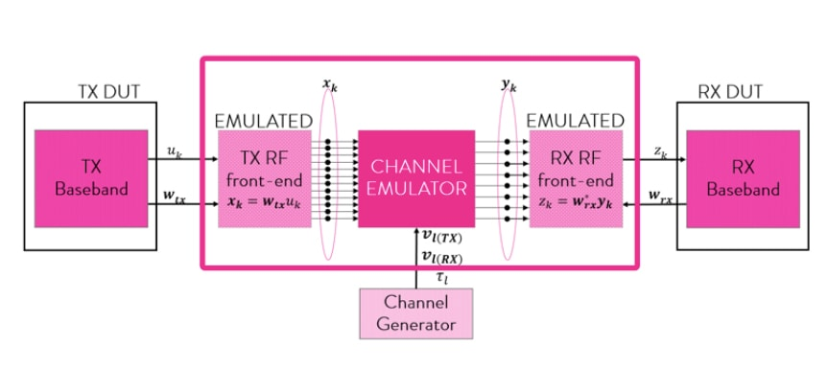

Figure 3: MIMO [29]

* **RIS**

A RIS is a surface with a grid of passive reflecting devices that can alter the incoming signal's phase individually [30] [31]. The RIS could be broken down into antenna-array-based structures and meta-surface-based structures depending on the materials used for the reflecting components [32]. These systems can employ a prediction to recommend a human action or a machine action. The constantly changing wireless propagation environment could be accommodated by real-time reconfiguration of the reflection coefficient of every element, made possible by recent advances in metamaterials. Figure 4 illustrates the process of RIS.

Figure 4: Architecture of RIS [33]

Following is a list of some of RISs' benefits:

1. **Easy to deploy:** Electromagnetic (EM) material is used to create RISs. Building exteriors, internal walls, roadside billboards, aerial platforms, car windows, highway polls, and even people's garments could all benefit from RIS deployment because of their cheap cost [34].
2. **SE enhancement: T**he conditions for wireless transmissions might eventually shift because of RIS's ability to mitigate power degradation over extended distances. The radio signals that are impinging on the Base Stations (BSs) can be actively reflected to create a virtual Line-of-Sight (LoS) link between the BSs and mobile users. When the LoS between BSs and users is obscured by barriers like tall buildings, then the throughput improvement becomes particularly prominent. An improved signal-to-interference-plus-noise ratio (SINR) could be achieved by the strategic placement and planning of RISs that provide a software-defined wireless environment.
3. **Environment friendly:** In contrast to traditional relaying methods, RISs can shape the incoming signal by precise control of the phase shift of each reflecting element [35]. Therefore, RIS deployment is better than traditional AF and DF systems from an environmental and EE perspective.
4. **Compatibility:** RISs can transmit in full-band and full-duplex (FD) configurations since it only reflects the EM waves. Higher wireless networks that use RIS are also backward well-suited to the hardware and standards of conventional wireless networks [36].

* **Orthogonal Time Frequency Space (OTFS) modulation**

Transmitter and receiver OTFS modulation consists of a series of two-dimensional transformations, as shown in below Figure 5. To move the data symbols x[n,m] from the delay-doppler phase to the time-frequency domain, the transmitter first does an inverse simple Fourier transform and a windowing operation. The time-frequency controlled signal is transformed into a time-domain signal s(t) using the Heisenberg transformation of X[n,m]. To demodulate signs, the delay-Doppler domain is used at the receiver after the time signal r(t) is Wigner-transformed into the time-frequency domain. Transmission channel effects on orthogonal frequency-sequence (OTFS) signals and time-frequency modification are investigated [37].

Figure 5: OTFS Modulation [38].

* **Orthogonal Frequency Division Multiplexing (OFDM)**

Digital multi-carrier modulation using OFDM is a widely used approach in today's digital communications. It's a promising method for future high-speed wireless communications. OFDM is widely used as a modulation technology in several wireless communication systems. Some examples are the Wireless Fidelity, the Mobile Worldwide Interoperability for Microwave Access network and the Digital Video Broadcasting (DVB) network.

Since the mobile digital broadcasting system can send not only music and video but also data and multimedia to mobile phones and other portable devices, it has received a lot of attention in recent years. OFDM degrades subcarrier orthogonality and creates Inter Carrier Interference (ICI) when the received signal's carrier frequency is shifted, as caused by, for example, doppler shifts or inconsistencies in the Local Oscillator (LO) [39].

* **Internet of Things (IoT)**

Since it was first suggested in 1999 by a member of the Radio Frequency Identification (RFID) research group, the IoT has become a more realistic possibility due to the development of mobile devices, and data analytics. Envision a future where billions of items are linked by IP networks that allow them to feel, communicate, and exchange data with one another [40]. IOT refers to a system of interconnected physical devices. The Internet has expanded from being simply a network of computers to smartphones, vehicles, toys, home appliances, medical instruments, cameras, animals, people, industrial systems, and buildings, all of which are linked together and exchange data according to predetermined protocols to facilitate smart reorganizations, tracing, safe and control, positioning, and online upgrades and even personal real-time online monitoring [41] [42].

1. **PROPOSED METHODOLOGY**

The approach used for the issue should also be assessed to get the generated output with properly modulated circuitry and generalized precise result. Figure 6 depicts the complete layout of the parameters and work that must be implemented to satisfy the desired need for 6G generation characteristics inside the channel module of propagation.

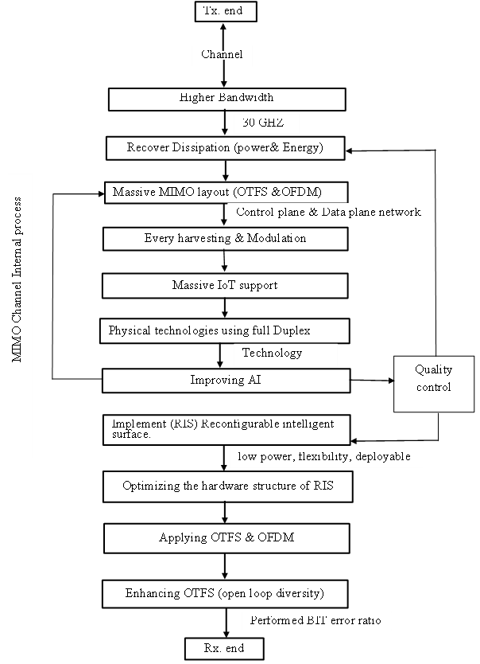

Figure 6 depicts the proposed methodology.

The step-by-step explanation of the proposed methodology is shown below:

1. At the transmitter end, desired data (input) is given into the channel for better propagation from the user's End.
2. For 6G propagation, the bandwidth needs to be enhanced through the packets of information transfer perfectly, with bandwidth up to the range of 30 MHz.
3. In any generation channel, there is always dissipation that took place which needed to be prevented or minimized by using the harvesting phenomenon.
4. OTFS and OFDM are the basic guidelines technique needed to be synthesized to enhance output in a 6G generation system.
5. Proper modulation and harvesting processes needed to be initialized and synthesized.
6. For 6G massive IoT support is needed to get proper updating across both the junction and mechanism that need to get installed.
7. Full-duplex data transmission is the provision of data in both directions on a signal carrier at the same time. "Full-duplex data transfer" describes this capability therefore this methodology is efficiently used and required in next-G technology.
8. AI which has been created to a very high level is necessary for 6G to automate the simultaneous conveyance of information for mass autonomy, human-machine interface, and focused healthcare. The network must be reliable if 6G is going to continue to spread into more and more important applications.
9. After analyzing all the MIMO internal modulation processes the process checks the Quality control parameters.
10. Deep learning and big data analytics would be two of the technologies that can be integrated into the 6G of cellular networks, which can bring together previously separate technologies.
11. Computing on the edge.
12. The IoT
13. **Computing on a very High-Performance Level** - It is unavoidable that 4G and 5G might be superseded by a more advanced cellular technology that can eventually be referred to as 6G. It can not only be able to use higher frequencies and significantly less latency in its communications, but it can also be able to provide a capacity that is significantly higher than either 4G or 5G. In addition to this, it can operate at frequencies that are higher than those used by 5G.

After analyzing all the parameter

If the MIMO layout satisfied these parameters, then the loop moves to the next step

Else, returned to dissipation-characterized structure to design a responsive analytical layout

1. Current research is focusing on RISs as a potential solution to the problem of converting the propagation area into a smart radio environment.
2. The principles of the RIS hardware design as well as its key advantages in contrast to relays are the primary reasons why it is important to turn the propagation area into a Smart Radio Environment (SRE) to achieve the desired varied output optimization.
3. Two common types of modulation methods are known as OFDM and OTFS modulation. These techniques are used to increase the data throughput and SE of a network. This technique is referred to as multicarrier modulation because, rather than using just one carrier, it makes use of many carriers.
4. Analyze the performance of the receiver when an open loop transmits diversity is being used.
5. On the physical layer, research is being done to explore the resultant Bit Error Rate (BER) behavior in 6G local mobile networks for direct data exchange.

Though across the channel range in a MIMO system modulated process normally took place in any G system mainly in the 6G generation also. Therefore, across the channel junction, the source of desired information efficiently reached the user end, and the 6G network efficiently moduled out.

1. **IMPLEMENTATION AND RESULTS**

This section of the research details the implementation carried out using the suggested technique, and the implementation tools are provided below.

* 1. **Tool Used**

In this section, the MATLAB tool is used to obtain the results. Engineers and scientists have long been the primary users of MATLAB, a programming environment designed specifically for them to research and develop world-altering systems and products. The core of MATLAB is the MATLAB language, which is a matrix-based language that allows for the clearest presentation of computer mathematics.

In this research, M-MIMO is a promising technology for next-generation wireless communication networks. It mixes multiple inputs and outputs. After explaining Massive MIMO in depth, examine EE, Hardware Efficiency (HE), and other practical deployment difficulties. First, a comprehensive but manageable canonical system model is offered.

**Result 1: Spectral Efficiency (SE) vs Mean square error comparison with higher bandwidth modulation (Antennas**)

Figure 7 shows the comparison between the Receivers' NMSE and a previous experiment mentioned in the background study. Three receivers outperform the two-coding-matrix method in NMSE. The recommended receivers efficiently use the orthogonal matrix G0K. Algorithm development and system model generalization were easy because the receiver's EW-MMSE was near the bottom bound. The methods can reveal space-time coding channel states (CSI). MMSE-SE (comparison) The duality gap causes the tiny performance difference between tradeoff techniques. The performance difference can decrease as the duality gap approaches zero and the number of subcarriers approaches infinity concerning the previous research as mentioned above shows transit change in the duality gap referred to above and also The MMSE estimators can suppress this interference and therefore function even with tighter reuse, whereas the LS estimator cannot suppress pilot interference by using spatial processing, making it more sensitive to pilot contamination. This explains why this proposed structure has better tuning efficiency and better SE response than previous research theologies.

Beamforming vectors for RIS hardware. Converging channels. Asymptotic channel capacity and power consumption models estimate energy efficiency. Linear receiver uplink scheduling aids MIMO. The simulations suggest that more-antennae MF receivers improve scheduling gain regardless of user selection or CSI availability. ZF receiver scheduling gain with high data demodulation channel estimation error and near-ideal CSI requires careful user selection. MIMO system size-varying algorithms such as ZF and CF are the fastest.

Figure 7: Comparison of the method to other technologies

**Result 2: Spectral Efficiency (SE) vs No. of base- station (Antennas)**

Figure 8 shows that when the basic condition of Nyquist is used to optimize the SE, the level of optimization drops slightly up when compared to the first graph. However, when distortion parameters are ignored, the second graph shows significantly improved optimization results for the number of base stations applied to the optimal range. When the fading correlation is present, it has a significant impact on the performance of MIMO systems and the efficacy of certain signal processing and channel coding approaches increases. In this analysis, the spatial channel correlation is considered. It allows for an accurate evaluation of the SE for a high-frequency range network, which is subsequently improved to account for the influence of hardware constraints in a MIMO working module.

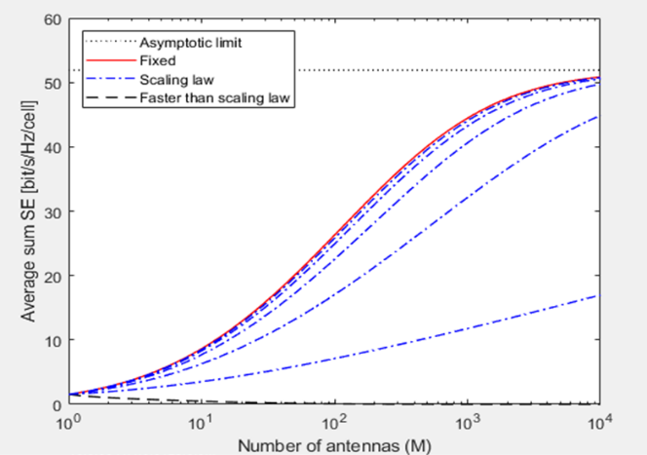

Figure 8: Antennas vs SE analysis

1. **CONCLUSION AND FUTURE SCOPE**

6G would enhance coverage as much as is practically possible by leveraging previously underused frequency bands and giving all network nodes greater intelligence. This would be accomplished by using the space segment as a component of the network design. In this paper, the design considerations that went into the creation of the next generation are broken down, along with the features that can be incorporated as well as the prospective software and hardware that would be employed. It explores the various applications of high-frequency technology and outlines the significant challenges associated with using them. The performance of MIMO systems is significantly impacted by the presence of the fading correlation, and the effectiveness of several signal processing and channel coding techniques is improved. The spatial channel correlation is taken into account in this analysis. It enables a precise assessment of the SE for a high-frequency range network, which is then enhanced to take the impact of hardware limitations in a MIMO working. The improvements in network performance and technological integration The improvements in network performance, technological integration, and service quality that come with the adoption of 6G technology would make it feasible to create a hyper-connected, intelligent society. In the future authors would include technological inefficiencies particular to very high-frequency bands, such as phase noise, into performance analysis and test MIMO's ability to increase throughput.